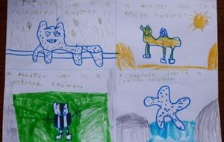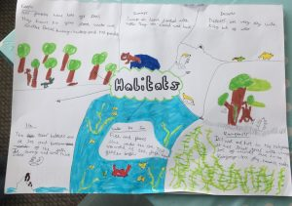

This week, the Year 2 children have been doing research on habitats. They discovered that a habitat is a place where an animal or plant lives. It provides the animal or plant with food, water, air and shelter. There are eight different types of habitat.
We challenged the Year 2 children to create a poster to show 4 animals in their natural habitats, like below:

Kingsleigh Primary school blog

